11.2 Position of equilibrium
Name: ____________________ Class: ____________________ Due date: 4.22
1. The formation of sulfur trioxide from sulfur dioxide is a reversible reaction.
$$2SO_{2}(g)+O_{2}(g)⇌2SO_{3}(g)$$
The forward reaction is exothermic.
$SO_{3}$Which changes would increase the equilibrium yield of ? （ ）
1 increasing the pressure
2 lowering the temperature
3 decreasing the concentration of oxygen
A 1,2 and 3 B 1 and 2 only C 1 only D 2 and 3 only

2. The formation of sulfur trioxide is a reversible reaction.
The equation is shown.
$$2SO_{2}(g)+O_{2}(g)⇌2SO_{3}(g)$$
The forward reaction is exothermic.
Which conditions produce the highest equilibrium yield of sulfur trioxide? （ ）
 | pressure | temperature
A | high | high
B | high | low
C | low | high
D | low | low

3 .Sulfur dioxide reacts with oxygen at 2 atmospheres pressure. The forward reaction is exothermic.
The equation for the reaction is shown.
$$2SO_{2}(g)+O_{2}(g)⇌2SO_{3}(g)$$
The reaction reaches equilibrium. The pressure is then doubled.
How and why does the amount of sulfur trioxide formed change? （ ）
 | amount of sulfur trioxide | reason
A | decreases | the forward reaction is exothermic
B | decreases | there are fewer molecules on the right
C | increases | the forward reaction is exothermic
D | increases | there are fewer molecules on the right

4 . Methanol is prepared by the reversible reaction shown.
$$CO(g)+2H_{2}(g)⇌{CH}_{3}OH(g)$$
The forward reaction is exothermic.
Which conditions produce the highest equilibrium yield of methanol? （ ）
 | temperature | pressure
A | high | high
B | high | low
C | low | high
D | low | low

5. The reversible reaction between methane and steam is shown.
$${CH}_{4}(g)+H_{2}O(g)⇌CO(g)+3H_{2}(g)$$
The forward reaction is endothermic.
Which changes in pressure and temperature move the equilibrium to the right?（ ）
 | pressure | temperature
A | decrease | decrease
B | decrease | increase
C | increase | decrease
D | increase | increase

6. The graph shows how the yield of product in a reversible reaction changes as the temperature and pressure are changed.
All reactants and products are gases.
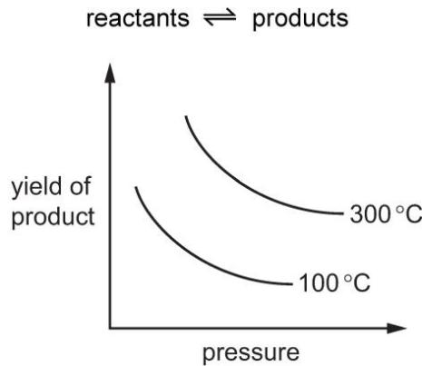
Which row is correct for this reversible reaction? （ ）
 | side of reaction with fewer moles | forward reaction
A | reactant | exothermic
B | reactant | endothermic
C | product | endothermic
D | product | exothermic

7. The reaction between sulfur dioxide and oxygen is shown.
$$2SO_{2}(g)+O_{2}(g)⇌2SO_{3}(g)$$
The reaction is exothermic.
Which of the changes shifts the position of equilibrium to the right? （ ）
1 Increase the concentration of oxygen.
2 Increase the pressure.
3 Increase the temperature.
A 1,2 and 3 B 1 and 2 only C 1 and 3 only D 2 only

8. The equation shows the equilibrium between dinitrogen tetroxide, N₂O₄, and nitrogen dioxide,NO₂
${NO}_{2}$$N_{2}O_{4}$At room temperature, the conversion of nitrogen dioxide, , into dinitrogen tetroxide, , is reversible.
$$2{NO}_{2}(g)⇌N_{2}O_{4}(g)$$
Brown gas colourless gas
The forward reaction is exothermic.
Which changes cause the equilibrium to shift to the left? （ ）
 | pressure | temperature
A | decrease | decrease
B | decrease | increase
C | increase | decrease
D | increase | increase

9. Chloride P is converted to chloride Q by reaction with chlorine in a closed system.
The reversible reaction reaches an equilibrium.
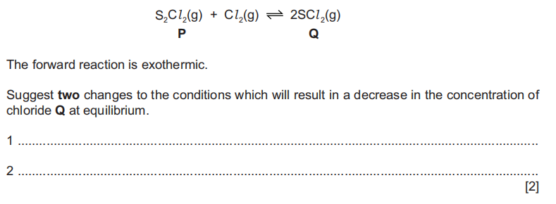

10. Nitryl chloride, NO₂Cl, reacts with nitric oxide, NO.
The forward reaction is exothermic
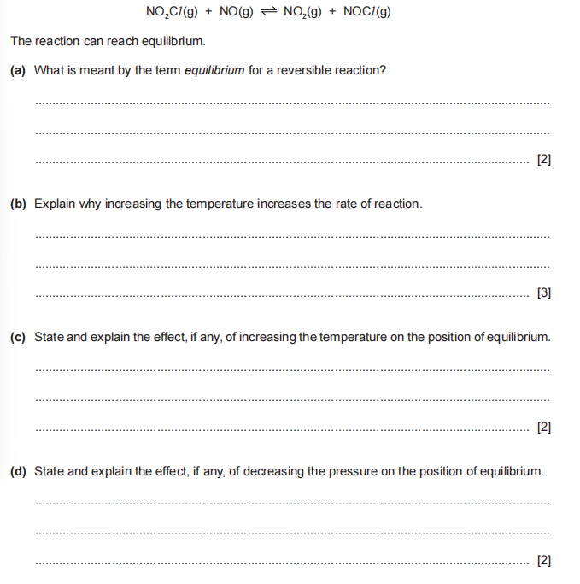
The reaction can reach equilibrum.
(a)What is meant by the term equilibrium for a reversible reaction?
..................................................................................................................................
..................................................................................................................................[2]
(b)Explain why increasing the temperature increases the rate of reaction
..................................................................................................................................
..................................................................................................................................
..................................................................................................................................[3]
(c)State and explain the effect, if any, of increasing the temperature on the position of equilibrium.
..................................................................................................................................
..................................................................................................................................[2]
(d) State and explain the effect, if any, of decreasing the pressure on the position of equilibrium.
..................................................................................................................................
..................................................................................................................................[2]

${NO}_{2}$$N_{2}O_{4}$11. Nitrogen dioxide,, exists in equilibrium with dinitrogen tetroxide, .
Nitrogen dioxide is brown and dinitrogen tetroxide is colourless.
$$\begin{matrix}2{NO}_{2}(g)⇌N_{2}O_{4}(g) \\ brown colorless\end{matrix}$$
i. A sample of nitrogen dioxide and dinitrogen tetroxide at equilibrium was placed in a closed gas syringe. The syringe plunger was pushed in. This increased the pressure in the gas syringe. The temperature was kept constant.
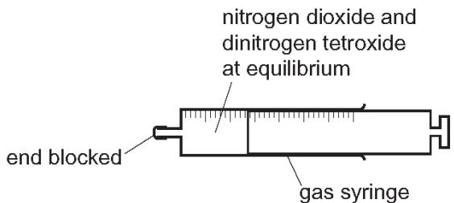
State how the colour of the gas in the syringe changed. Explain your answer in terms of the position of the equilibrium.
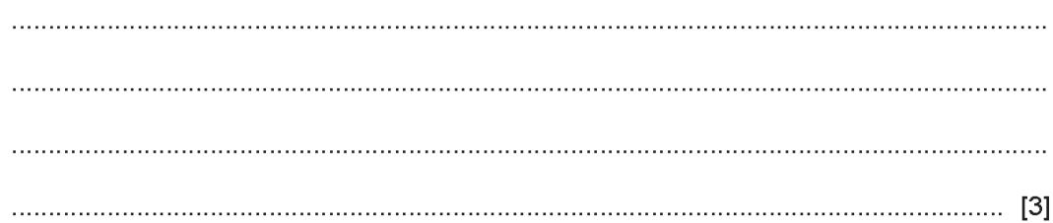
ii.A sealed tube containing nitrogen dioxide and dinitrogen tetroxide at equilibrium was cooled in an ice bath at constant pressure. The contents of the tube became paler.
Suggest an explanation for this observation in terms of the position of the equilibrium.
